STUDENT EXCUSE GENERATOR

BUG 1 – Takes only First name.
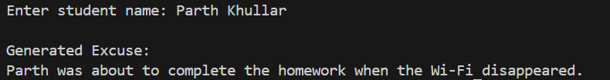
Prompt - Help me fix the bug , where only first name is coming as the output rather than the full name.
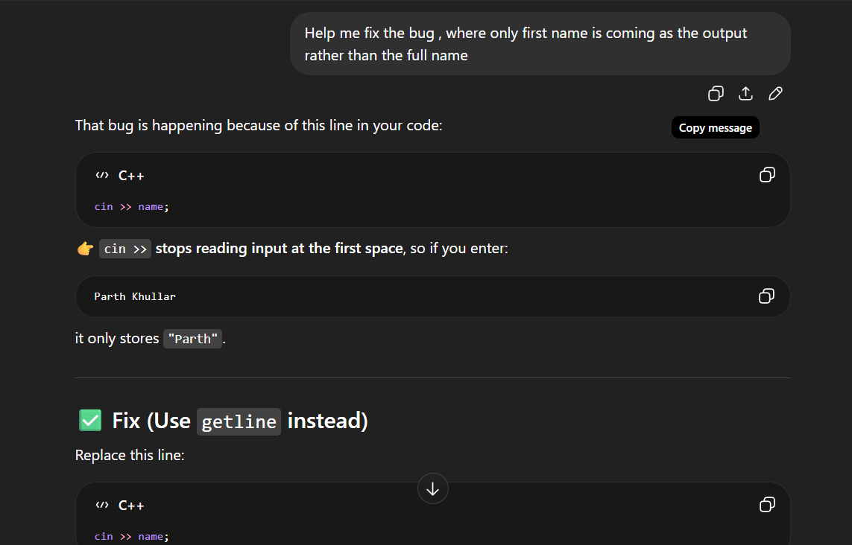
Correct Answer –
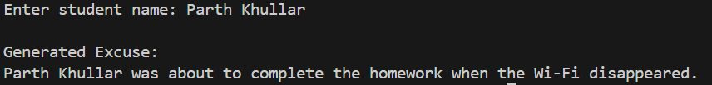

BUG 2 – Same output coming again and again
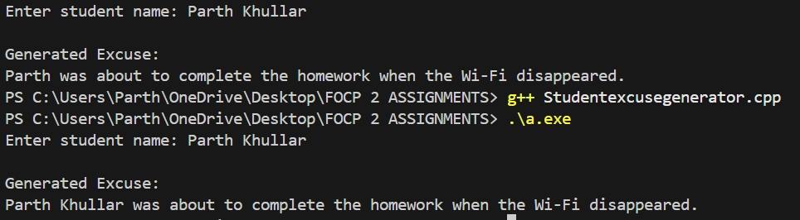
Prompt - Help me solve the problem where same output is coming again and again.
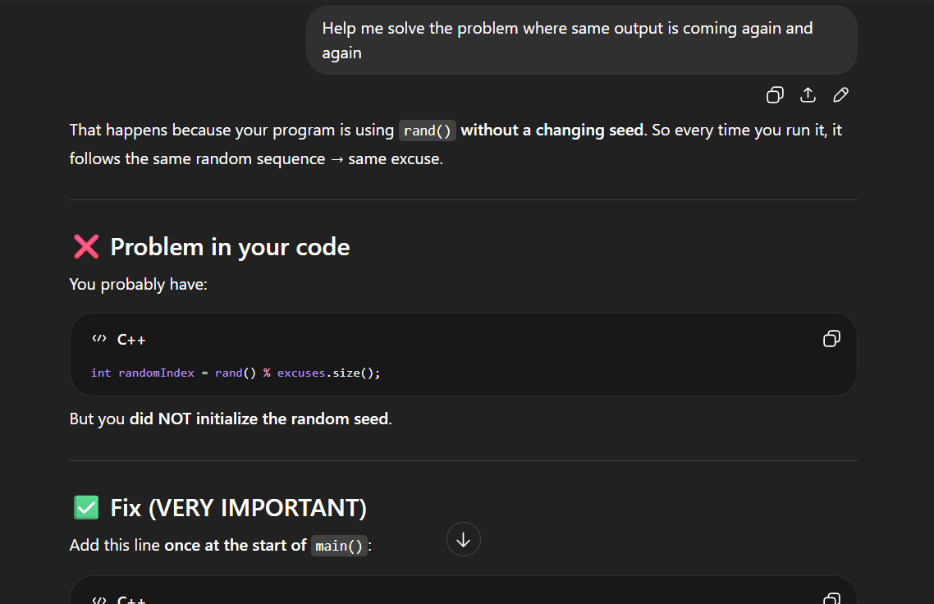
Correct Answer –
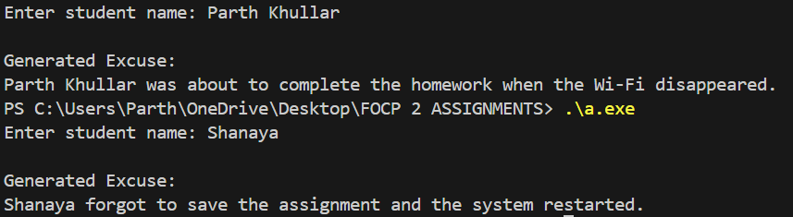

BUG 3 – Replaces only first occurrence of {name}
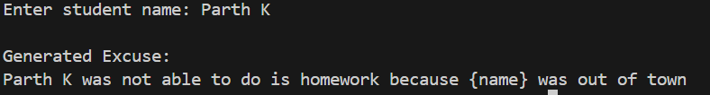
Prompt - Help me solve the problem - only first occurrence of {name} is replaced
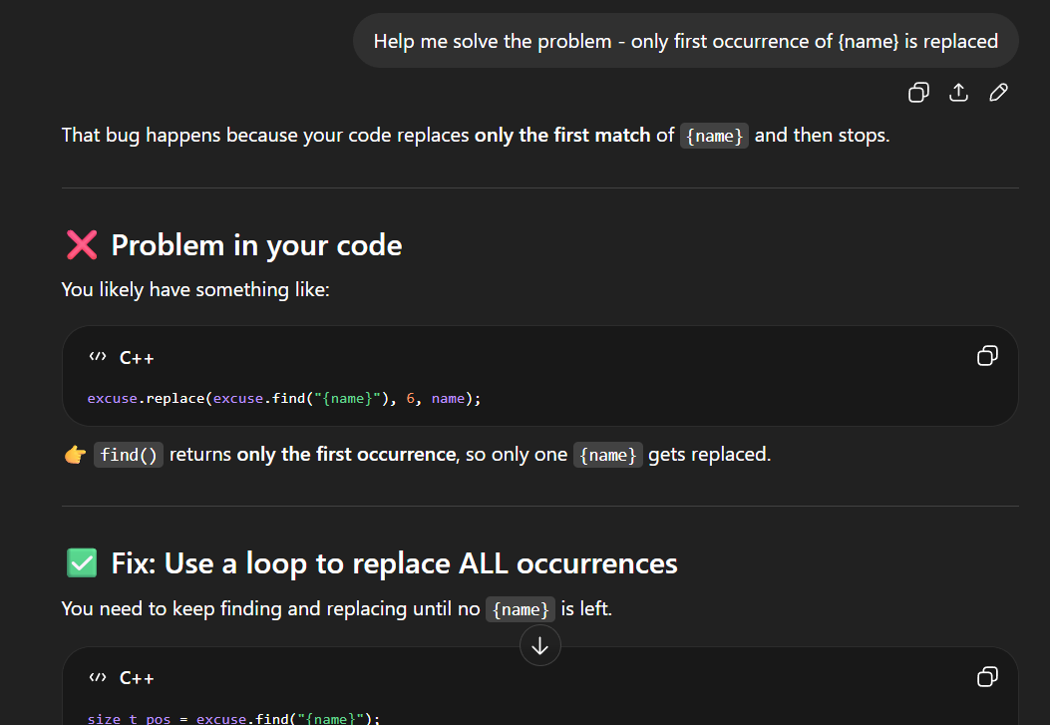
Correct Answer –
